Q1

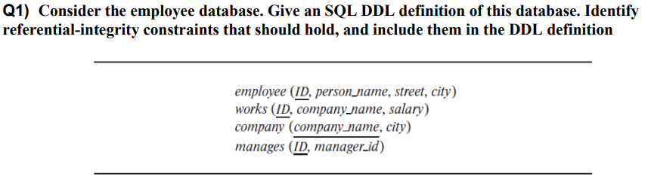

CREATE TABLE employee (

ID INT PRIMARY KEY,

person_name VARCHAR(100),

street VARCHAR(100),

city VARCHAR(50)

);

CREATE TABLE company (

company_name VARCHAR(100) PRIMARY KEY,

city VARCHAR(50)

);

CREATE TABLE works (

ID INT,

company_name VARCHAR(100),

salary DECIMAL(10, 2),

PRIMARY KEY (ID, company_name),

FOREIGN KEY (ID) REFERENCES employee(ID) ON DELETE CASCADE,

FOREIGN KEY (company_name) REFERENCES company(company_name) ON DELETE CASCADE

);

CREATE TABLE manages (

ID INT,

manager_id INT,

PRIMARY KEY (ID, manager_id),

FOREIGN KEY (ID) REFERENCES employee(ID) ON DELETE CASCADE,

FOREIGN KEY (manager_id) REFERENCES employee(ID) ON DELETE SET NULL

);

Q2

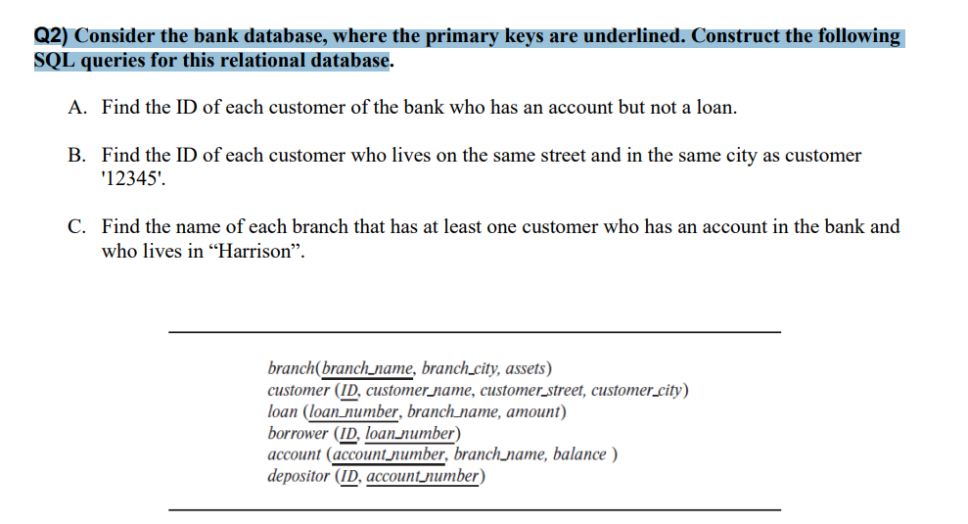

1-

SELECT DISTINCT ID

FROM depositor d

WHERE NOT EXISTS (

SELECT 1

FROM borrower b

WHERE b.ID = d.ID);

2-

SELECT c2.ID

FROM customer c1

JOIN customer c2 ON c1.customer_street = c2.customer_street

AND c1.customer_city = c2.customer_city

WHERE c1.ID = '12345' AND c2.ID != '12345';

3-

SELECT DISTINCT branch_name

FROM account

WHERE account_number IN (

SELECT account_number

FROM depositor

WHERE ID IN (

SELECT ID

FROM customer

WHERE customer_city = 'Harrison'

)

);

Q3

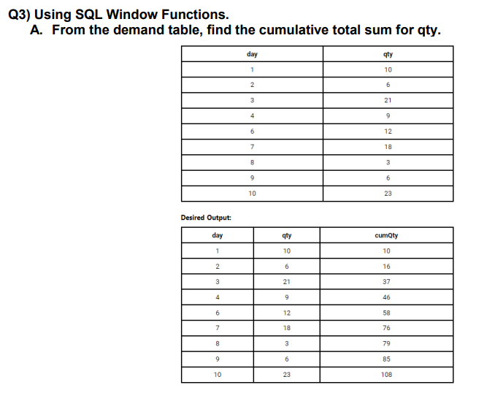

SELECT

day,

qty,

SUM(qty) OVER (ORDER BY day) AS cumQty

FROM

demand;

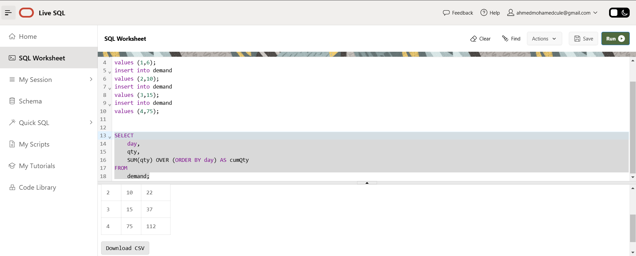

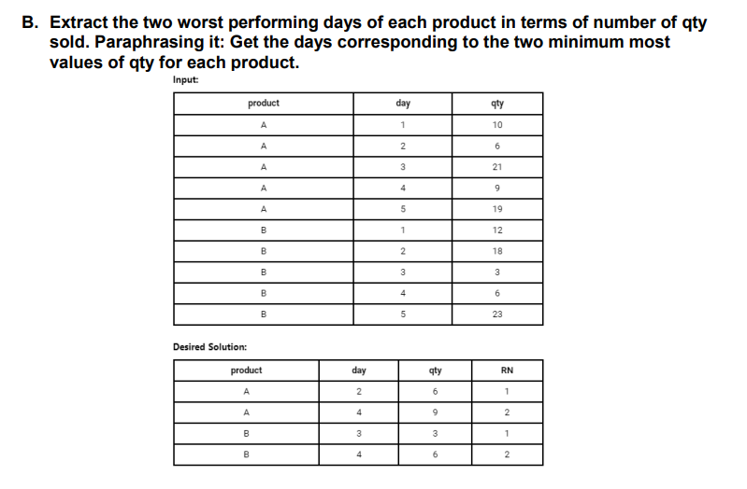

SELECT product, day, qty, RN

FROM (

SELECT product, day, qty,

ROW_NUMBER() OVER (PARTITION BY product ORDER BY qty ASC) AS RN

FROM sales

) AS ranked_data

WHERE RN <= 2

ORDER BY product, RN;